Name: PAWAN KUMAR MEENA

Father’s Name : KAMLESH KUMAR MEENA

Roll No : 21UFIE2085

Branch : Comouter Science And Engineering

1. **INTRODUCITON:**

**1. C program to print Hello Word!**

**Program:**

#include <stdio.h>

int main()

{

printf("Hello Word!\n");

return 0;

}

**Output:**

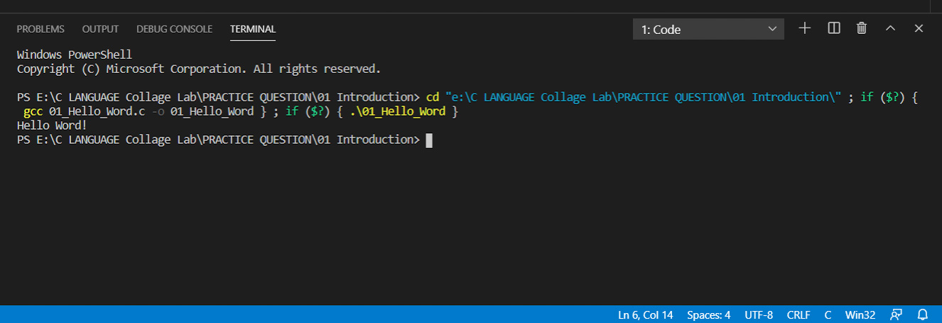

**2. C program to Add Two Integers.**

**Program:**

#include <stdio.h>

int main()

{

int num1, num2, sum;

printf("Enter the first number:\n");

scanf("%d", &num1);

printf("Enter the second number:\n");

scanf("%d", &num2);

sum = num1 + num2;

printf("Sum of %d and %d = %d\n", num1, num2, sum);

return 0;

}

**Output:**

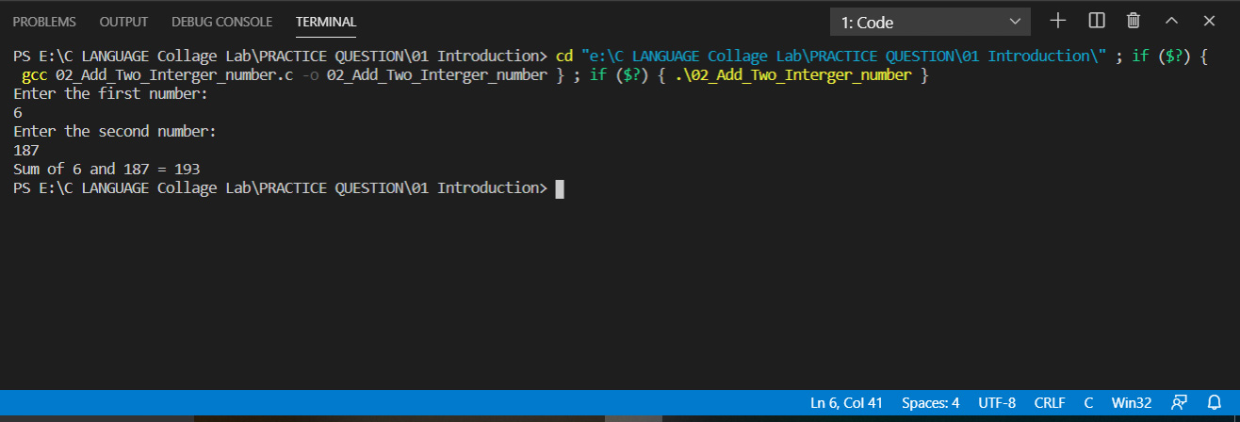

1. [**C Program to Multiply two Floating Point Numbers**](https://www.programiz.com/c-programming/examples/product-numbers)**.**

**Program:**

#include <stdio.h>

int main()

{

float num1, num2, result;

printf("Enter the first number:\n");

scanf("%f", &num1);

printf("Enter the second number:\n");

scanf("%f", &num2);

result = num1*num2;

printf("Multiplaction of %0.2f and %0.2f = %0.3f",num1,num2,result);

return 0;

}

**Output:**

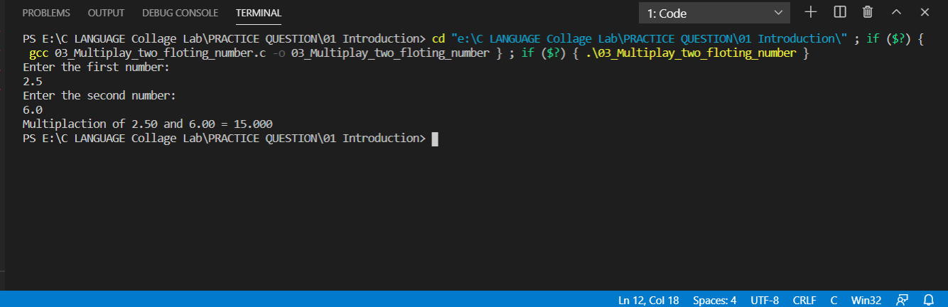

1. [**C Program to Find ASCII Value of a Character**](https://www.programiz.com/c-programming/examples/ASCII-value-character)**.**

**Program:**

#include<stdio.h>

int main (){

char ch;

printf("Enter the character:\n");

scanf("%c",&ch);

printf("ASCII Value of character %c = %d",ch,ch);

return 0;

}

**Output:**

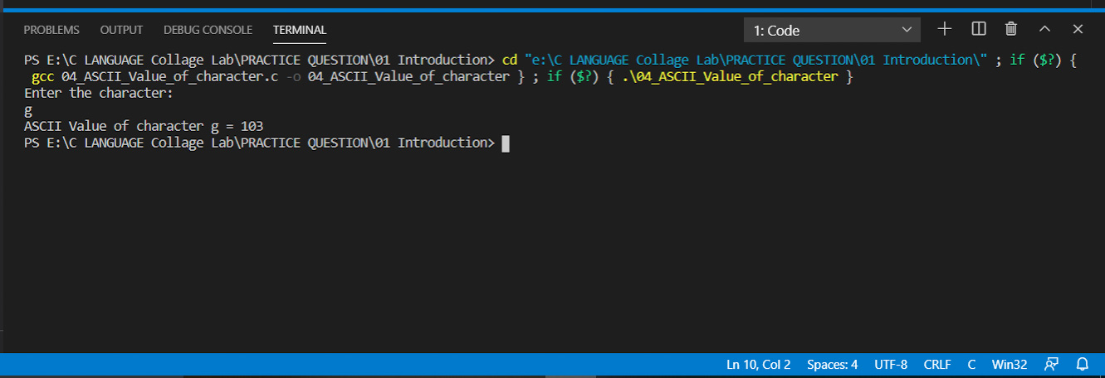

**5.**[**C Program to Find the Size of int, float, double and char**](https://www.programiz.com/c-programming/examples/sizeof-operator-example")

**Program:**

#include <stdio.h>

int main()

{ int x, y, z, w;

x = sizeof(int);

y = sizeof(float);

z = sizeof(char);

w = sizeof(double);

printf("Size of a interger number = %d\n", x);

printf("Size of a float number = %d\n", y);

printf("Size of a character number = %d\n", z);

printf("Size of a double number = %d\n", w);

return 0;

}

**Output:**

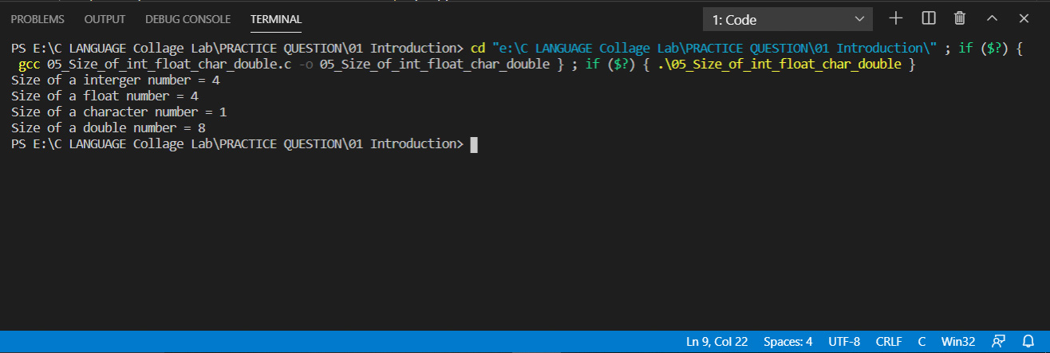

**6.** [**C Program to Swap Two Numbers**](https://www.programiz.com/c-programming/examples/swapping) **using temporary variable.**

**Program:**

#include <stdio.h>

int main()

{

int num1, num2, temp;

printf("Enter the first number:\n");

scanf("%d", &num1);

printf("Enter the second number:\n");

scanf("%d", &num2);

printf("\n****Value before sweaping**** \n");

printf("Value of first number = %d\n", num1);

printf("Value of second number = %d\n", num2);

temp = num2;

num2 = num1;

num1 = temp;

printf("\n****Value after sweaping**** \n ");

printf("Value of first number = %d\n", num1);

printf("Value of second number = %d\n", num2);

return 0;

}

**Output:**

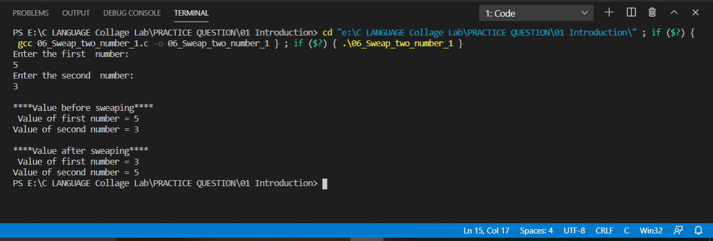

**7.** [**C Program to Swap Two Numbers**](https://www.programiz.com/c-programming/examples/swapping) **without using temporary variable.**

**Program:**

#include <stdio.h>

int main()

{

int num1, num2;

printf("Enter the first number:\n");

scanf("%d", &num1);

printf("Enter the second number:\n");

scanf("%d", &num2);

printf("\n****Value before sweaping**** \n ");

printf("Value of first number = %d\n", num1);

printf("Value of second number = %d\n", num2);

num1 = num1+num2;

num2 = num1-num2;/*value of number 1st store in num2*/

num1 = num1-num2;/*value of nuber 2nd store in num1*/

printf("\n****Value after sweaping**** \n ");

printf("Value of first number = %d\n", num1);

printf("Value of second number = %d\n", num2);

return 0;

}

**Output:**

